**Introduction**

This study conducted as a doctoral thesis in 2012, explored issues concerning the low uptake of nurse prescribing in mental health services, and why nurses fail to prescribe after successfully completing the non-medical prescribing course.

This study was conducted in an NHS Trust in the north of England. At the time of the initial development stage of this research, the Trust specialised in the secondary care and treatment of people with mental health and learning disabilities issues, providing inpatient and community services across a large geographical area. In 2011, the Trust expanded its clinical services to include primary care services, within one of its geographical locations.

**Background**

Non-medical prescribing within UK health services enables suitably trained healthcare professionals to effectively use their skills and competencies to improve patient care in a range of settings. Currently nurses, pharmacists, optometrists, physiotherapists, chiropodists or podiatrists, radiographers and community practitioners can undertake further professional training to qualify as non-medical prescribers (DH, 2006).

Nurse prescribing is an established intervention throughout the world; it began in the UK after over 20 years of development (McDougall and Ryan, 2016). Nurse prescribing is an extension to the nurse’s role; however, the uptake of this extension of the Mental Health Nurse’s (MHN’s) role has been poor with few undertaking the qualification. Of the few nurses that qualify, even fewer prescribe (Dobel-Ober et al., 2013). Whilst there has been an overall growth in numbers of nurse prescribers more recently, there remains large variance in numbers between organisations (Dobel-Ober et al., 2016).

Previous research around MHN prescribing spent considerable effort either on validation of or arguing against the need for prescribing rights. Subsequent research focussed on political issues, or questioned competence, role conflict, and public safety (Snowden and Martin, 2010), or focussed on the MHN’s competence and the views of service users towards nurse prescribing (Earle et al., 2011).

The majority of participants in nurse prescribing research were prescribers and the views of non-prescribing nurses are not well represented (Bowskill, 2009). Whilst the studies did consistently highlight recurring themes, they did not explore with nurses themselves why some MHN’s prescribe, whilst others choose not to. Given that we currently do not know why qualified independent prescriber, do not prescribe, the aim of this study was to explore reasons for tis phenomena, from the perspective of the non-prescribing MHN prescribers.

**Method**

A qualitative approach was used in this research, utilising descriptive, exploratory methods.

Qualitative studies provide descriptions and interpretations of peoples’ experiences (McCauley-Elsom et al., 2009). This study was conducted in two phases, within one NHS Trust.

* Phase 1: a mapping exercise in the Trust, used to identify potential participants, and describe the current mental health workforce prescribing and non- prescribing status. In conjunction with this, relevant Trust policy documents were reviewed and analysed.
* Phase 2: the qualitative section, via in-depth interviews.

**Sample**

Purposive sampling was utilised for individuals with specialist knowledge of this subject area and an insight into the reasons why qualified MHN prescribers have not prescribed.

This study identified ten potential participants from the results of the mapping exercise conducted as phase 1.

Inclusion criteria

Registered MHN’s also registered as nurse prescribers, who have never prescribed.

Table 1.



Ten prescribers were eligible, seven prescribers initially agreed to participate and consented to the study; one later withdrew, leaving six non-prescribing MHN prescriber participants.

**Data Collection**

**Phase 1**

A mapping exercise was conducted of the Trust’s non-medical prescribers. The exercise aimed to identify potential participants for phase two of this study.

**The aims of the phase 1 mapping exercise were to:**

Locate the population of nurse prescribers within the Trust, to ascertain their prescriptive authority and identify their medical supervisors.

At this time, the Trust was involved in the Department of Health’s Transforming Community Services initiative (DH, 2009). A result of the initiative meant that provider arms of the Primary Care Trust’s (PCTs) were transferred to organisations which were service providers. The effect of this on the Trust was that a number of practicing adult nurse prescriber’s joined the Trust.

**Inclusion criteria**

All non-medical prescribers registered with the Trust qualified as either an Independent or Supplementary prescriber (V200 or V300).

**Phase 2 – Data collection**

This was done by semi-structured interview, which allowed the follow up of issues raised by participants that the researcher had not been anticipating (Tod, 2015).

**Ethical considerations**

Ethical approval to conduct this study was obtained from a University research ethics committee. Due to the small sample size, the ethical issue was the protection of the participant’s identity. Pseudonyms were employed with un-gendered names to protect participant’s identities. NHS ethics approval was not required as the participants were NHS staff recruited as research participants by virtue of their professional role and were therefore excluded from the normal remit of NHS Research Ethics Committees (National Research Ethics Committee Service, 2012, p. 3).

**Data analysis**

Descriptive phenomenology was employed and the interpretation described by Colaizzi (1978) was broadly followed to guide the analysis. There are seven steps in Colaizzi analysis these are:

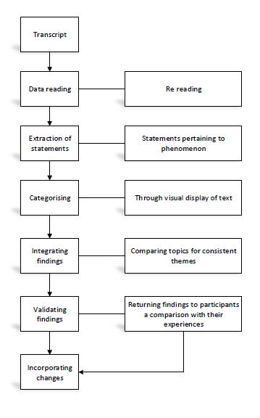

Figure 1: The seven steps of descriptive phenomenology analysis described by Colaizzi (1978, cited by Ross, 2012, p.124)

**Trustworthiness**

Internal validity was ensured by asking participants if they felt that a true record of their interview had been recorded, and by peer review, through another member of the research team reanalysing the raw data and comparing their findings with the researcher.

**Results Phase 1**

There were 659 qualified MHN’s within the Trust, of which 42 (6.4%) are Nurse Prescribers. The number of nurses, who have qualified as nurse prescribers, is lessened by the number of nurses who are prescribing, 42 down to 29 (4.4%). Almost a quarter 10 (24%) of those qualified as nurse prescribers had never prescribed.

The study participants were non-prescribing MHN prescribers identified from the phase 1 mapping exercise. There was an even gender mix between the participants and they ranged from band 6 to band 8b under the Agenda for Change pay scale (see table 2).

|  |  |  |  |  |
| --- | --- | --- | --- | --- |
| **Gender** | **Number** | **Band 6** | **Band 7** | **Band 8b** |
| Female | 3 | 1 | 1 | 1 |
| Male | 3 | 2 |  | 1 |

Table 2: Demographics of participants: pay banding and gender

**Results Phase 2**

The findings from phase 2 in-depth interviews were analysed to comprehend the phenomena. The analysis demonstrated three main themes: knowledge and power; culture; and structure and agency.

Table 3 Themes developed:

|  |  |
| --- | --- |
| **Main theme** | **Sub- themes** |
| Knowledge and Power within mental health settings | Role extension  Relationships  Training/Competence  Strengthening the nurse’s role |
| Culture within mental health settings | Mental health nursing culture  Prescribing authority  Organisational culture |
| Structure/Agency within mental health settings | Qualification Collectors  Cheap labour/remuneration  Personal considerations |

**Knowledge and Power**

This theme consists of four main sub-themes comprising: role extension; relationships; training/competence and strengthening the nurse’s role. The sub theme*, role extension* refers to participants’ views on their experience of nurse prescribing as an extension to their role. The sub theme of *relationships* refers to participants’ description of how nurse prescribing has affected their relationships with nursing colleagues and medical staff. The sub theme training/competence refers to participants’ views on their training and competence issues. Finally, the sub theme of *strengthening the nurse’s role* refers to participants’ views on nurse prescribing as a means to strengthening the nurse’s role.

The level of prescribing authority granted to MHN’s has not been an area of previous in depth discussion. The experience described by Alex, Sam and Fran raises the issue of prescriptive authority. They report that when they agreed to undertake the non-medical prescribing course, they thought that on qualification they would be independent prescribers:

*I thought that the way it was portrayed, was that I would be independent prescribing. I will be going out to see patients, giving them prescriptions, start them on their medication straight away. Well, I did the course, and when I got back from the course, it was obviously going to have to be supplementary prescribers first. (Alex).*

*….You know- going into it - sort of - not fully aware that you know would be supplementary prescribing. (Sam)*

Within the sub theme relationships, the influences on the decision to prescribe or not were discussed by all participants during the interview. They described how the reactions of medical colleagues affected their perceptions of nurse prescribing and influenced their decision not to prescribe.

*If a doctor is threatened by the nurse prescribing then I am sure it will affect the nurse’s decision to prescribe. (Viv)*

*When (previous consultant psychiatrist) was here, they were very approachable; and they were a lovely person. it was a bit like that - following doctor’s orders. But I think these two new ones, very amenable to discussion. Yes I think it is going to be about personalities. (Lou)*

*I think with my current consultant, I can’t imagine that they would be happy - really with me making decisions. (Alex)*

Within the sub theme training/competence, nurses have to show that they have sufficient assessment and diagnostic skills in the specialist area they will prescribe in (RCN, 2014).

The nurses were split on their views as to whether they thought the non-medical prescribing course prepared them for their prescribing role. Those in agreement responded:

*I was quite pleasantly surprised how a really good course it was, it was a really practical course and it really only taught you the things you needed to know, the anatomy and physiology, how all drugs work, ethics, I think it really did prepare me. Surprisingly actually, because I thought, well, I would have thought we would have spent all the time talking about one medication and one condition, but actually it was the opposite really. (Fran)*

Those who disagreed with the view that the non-medical prescribing course had prepared them to be nurse prescribers thought:

*I think it was generally useful from a legal medical point of view but not really - no. It was very physically orientated completely – there was no mental health that debate of mental health or substance misuse…and all the complexities that brings – so no not really. (Viv)*

The issue whether nurse prescribing strengthened the role of nurses within mental health services was an area where differing opinions were held in this study.

Whether or not MHN’s prescribe in the supplementary form (which was the only model for MHN’s that the Trust initially sanctioned), offered any type of broader responsibility.

One participant didn’t think so:

*I suppose in a sense it gives the nurse a sort of broader responsibility, but then actually, I am not convinced it does. I think a lot of it – particularly supplementary prescribing does depend very much on the relationship with the RMO (Responsible Medical Officer), because at the end of the day, it’s their gift what you can prescribe. I am aware of cases anecdotally, you know some nurses are limited to a particular drug at a particular dose and that is all they can prescribe. Other cases, where the clinical management plan will say any antidepressant within BNF (British National Formulary) guidelines. So, it very much depends on the leeway the doctor wants to give. (Sam)*

Overall, participants felt that nurse prescribing within mental health was positive. Not only did they express the view that prescribing made them ‘more holistic’ (Fran) in their approach. One participant thought that patients got *‘a better deal’, with a ‘far better understanding of the drug they were being prescribed’ and ‘far better support’* (Alex).

**Culture**

This theme presents data generated on cultural influences within the health system that affect the mental health nurse prescriber. The participants’ responses to how the organisational culture – pertaining to nurse prescribing - has affected their decision not to prescribe.

Within this study, the hierarchical nature of the professional relationship between the nurse and doctor, which is very closely related to the theme knowledge and power, is still evident:

*‘I think it is subservient absolutely, there’s still a huge power base in medicine over nursing hell of a difference and ….. it depends on the roles where some community workers very rarely consult and they work completely autonomously – others don’t and again it comes back to, even though it’s the same qualification, it comes back to organisational will.’ (Viv)*

Nurse prescribing as a means to a cultural shift in the hierarchical position of the nurse and doctor:

*I think it (nurse prescribing) – yes it gives a nurse a formal rounded ability to meet a patient’s needs, certainly with independent prescribing, fully independent prescribing it can divorce the need and cut those apron strings from medic. (Chris)*

The analysis of collected data revealed that mental health services only granted their nurse prescribers’ supplementary prescribing authority - level of authority given played a key role in the participants’ decisions not to prescribe.

Those in a position to prescribe felt the lack of independent prescribing authority influenced their decision not to prescribe. The practical difficulties of supplementary prescribing prevent its use. The inconvenience of preparing the clinical management plan:

*I didn’t have the time to go through the – what would you call them – hoops that supplementary prescribing would need……so one of the reasons I didn’t start*

**Structure/Agency**

Some participants were concerned that this extra skill set would leave them vulnerable to being moved to a different locality in the organisation to cover other non-medical prescribing nurses:

*One reason, one thing that I’ve held – sort of like back, me back and my other colleague who prescribes who’s not prescribed was certainly with the configuration the Trust set up in the nurse led clinics. Sort of, reconsideration of the mental health service, obviously at that time there were a hell of a lot of rumours and a lot of sort of ‘Chinese whispers’ going around. And one of the things that made me hold back with the nurse prescribing was a concern that there might not be enough prescribers in the Trust. So the people who were qualified to prescribe might find themselves being sort of like, seconded to the nurse led clinic. And that’s not an area where I wanted to work or want to work. You know, I like where I work now – most of the time. So that did have an impact – it’s like historically you know – that did hold us back you know make us think like this. You’re going from a place where you move around the community and actually I’ve a bit of freedom and fresh air than being stuck in a clinic from 9.00 – 5.00 pm. (Sam)*

Others decisions to not prescribe were concerned with their clinical post, and the work this entailed, nurse prescribing was not seen by Viv as being appropriate for their new clinical role:

*Well, if I’d have continued in the same job, I would have done. I was in the process of starting to get relocation but medical prescribing changed positions within this job, so I had a very clear decision about whether I pursue prescribing or whether I don’t in this particular role - the model I work with. And in developing it there is no call for prescribing because it goes against the whole idea of supporting other teams rather than being a specialist team. So there is no scope in this model. That’s why I don’t prescribe. So there is no way I could maintain prescription or review medications in the model I am working with. Is working with all the teams and the care co-ordinators rather than me being responsible for medicines, so no, even if the opportunity came, it wouldn’t fit in this working way. (Viv)*

**Discussion**

Mental health nursing continues to conform to many well-defined aspects of the profession such as education, care delivery approaches or systems and hierarchical structures. The foundations of mental health nursing have played a part in its development (Crawford et al., 2008).

Mental health nurses have developed a professional base, leading to clinical nurses redefining their role. This seems to be an issue when the mental health nurse feels the need to choose between a psycho-therapeutic or pharmaco-therapeutic role.

MHN’s, who wanted to become nurse prescribers, did so when the Transforming Community Services Initiative (DH, 2009) brought in an influx of general nurses who were already independently prescribing. It is argued that this brought in a change in the expectations of the MHN prescribers and their prescriptive authority by the Trust.

The theoretical framework highlights the attempt of mental health nursing to construct an identity and develop a working model that fits the work they do regarding prescribing (see diagram 1).

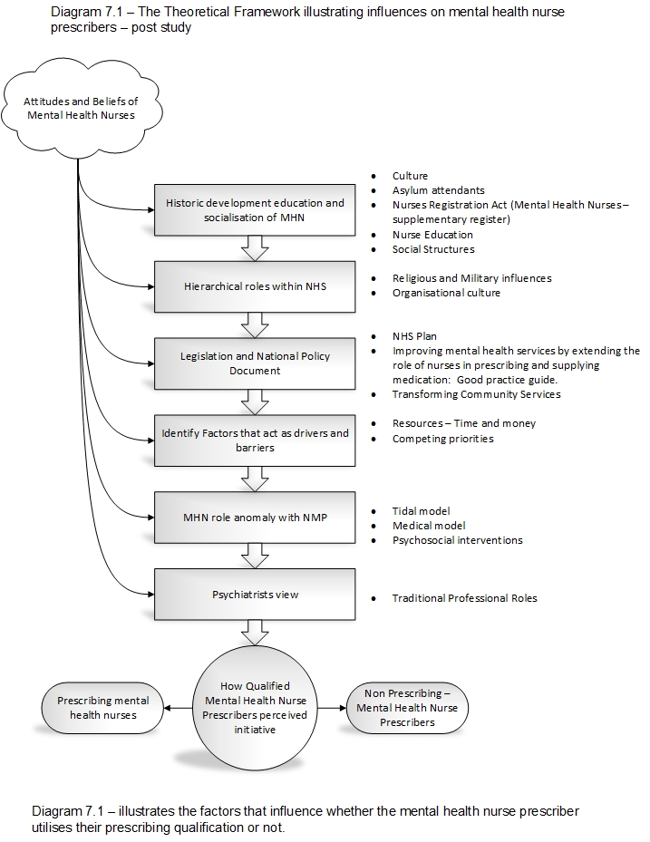

Diagram 1 – illustrates the factors that influence whether the MHN prescriber utilises their prescribing qualification or not.

It has been proposed that nurse prescribing has moved the nurse from a subservient towards an equal role with medicine in healthcare (DH, 2005). The resultant changes to the traditional roles in healthcare have led to some medical professionals feeling threatened (Courtenay and Carey, 2009). These views are supported by the findings of this study. Another finding supported by this study is that MHN’s experience with their medical supervisor has been reported as a major influence of the nurse prescribing in practice (Kroezen et al., 2012).

Forchuk (2001, p.39) states that this ‘struggle exists between biological and psychotherapeutic approaches in the mental health literature generally. It is also based on the more philosophical question: should nursing follow medicine, or position itself in an alternative/complementary position?’ Tension between these positions could contribute to whether a MHN undertakes the nurse prescribing course. Commentators have expressed concern regarding the lack of uptake in nurse prescribing in mental health settings (RCN, 2013).

The introduction and development of nurse prescribing is a microcosm of the challenges that the nursing profession faces. The support of other professional groups and the employing organisation is important to the ease of any transformation. The implications of this study may range further than the issue of nurse prescribing, it may also impact on how future extensions to the role of mental health nurses need to be managed to achieve optimum success, for example the development and employment of the advanced nurse practitioner.

**Key finding**

General nurse prescribers were the impetus for the Trust to grant independent prescriptive authority to mental health nurses. The mental health nurses within the host organisation were prepared and willing to undertake independent prescribing. However the findings from this study suggest that there are complex, interlocking factors: power and knowledge; culture; and structure and agency, which may enable or prevent MHN prescribers from independently prescribing.

**Limitations**

The study was conducted within one NHS Mental Health Trust, so the findings were limited to this particular participant group, and therefore cannot be constituted as ‘generalisable’ to the wider population. It could also be argued that representation can only be made within the context of a NHS Trust.

**References**

Bowskill, D. (2009) *The Integration of Nurse Prescribing: Case Studies in Primary and Secondary Care*. University of Nottingham. Available at: <http://eprints.nottingham.ac.uk/11036/1/The_Integration_of_Nurse_Prescribing.pdf>

Courtenay, M. and Carey, N. (2009) ‘Nurse prescribing by children’s nurses: views of doctors and clinical leads in one specialist children’s hospital.’ *Journal of Clinical Nursing*. 18 pp.2668-2675.

Crawford, P., Brown, B. and Majomi, P. (2008) ‘Professional identity in community mental health nursing: a thematic analysis.’ *International Journal of Nursing Studies*. 45 (7), pp. 1055-1063.

Department of Health (2005) Improving Mental Health Services by extending the role of nurses in prescribing and supplying medication: Good Practice guide. Produced jointly by the: National Prescribing Centre, National Institute for Mental Health in England and the Department of Health.

Department of Health (2006) Improving Patients’ Access to Medicines: A guide to

implementing nurse and pharmacist independent prescribing within the NHS in England. London. Stationery Office.

Department of Health (2009) Transforming Community Services: Enabling New Patterns of Provision. Gateway Reference: 10850. HMSO, London. Available at: <http://www.thelancastermodel.co.uk/programs/Transforming%20Community%20Services%202009.pdf>

Dobel-Ober, D., Bradley, E. and Brimblecombe, N. (2013) ‘An evaluation of team and individual formularies to support independent prescribing in mental health care. ‘*Journal of Psychiatric and Mental Health Nursing.* 20 pp. 35- 40.

Dobel-Ober, D.and Brimblecombe, N. (2016) ‘National survey of nurse prescribing in mental health services; a follow-up 6 years on.’ *Journal of Psychiatric and Mental Health Nursing.* 23 pp. 378- 386.

Earle, E. A., Taylor, J., Peet, M.and Grant, G. (2011) ‘Nurse prescribing in specialist mental health (part 1): the views and experiences of practising and non-practising nurse prescribers and service users.’ *Psychiatric and Mental Health Nursing.* 18 (3), pp. 89–97.

Forchuk, C. (2001) ‘Evidence-based psychiatric/mental health nursing.’ *Evidence Based Mental Health*.4 pp. 39-40 doi: 10.1136/ebmh.4.2.39.

Kroezen, M., Francke, A. L., Groenewegen, P.P. and Dijk, L. (2012) ‘Nurse prescribing of medicines in western European and Anglo-Saxon countries: a survey of forces, conditioning and jurisdiction control.’ International *Journal of Nursing Studies*. 49 (8), pp.1002-1012.

National Research Ethics Committee Service (2012)*. Changes to the remit of Research Ethics Committees. Guidance for researchers, sponsors, Research and Development Offices and Research Ethics Committees.* National Research Ethics Service.

McDougall, T. and Ryan, N. (2016) ‘Nurse prescribing in CAMHS: An evolving role.’ *British Journal of Mental Health Nursing.* 5 (2),pp.62-67.

Ross, J. and Kettles, A.M. (2012) ‘Mental health nurse independent prescribing: what are nurse prescribers' views of the barriers to implementation?’ *Journal of Psychiatric and Mental Health Nursing*. 19 (10), pp. 916-932.

Ross, T. (2012) *A Survival Guide for Health Research Methods.* McGraw Hill. Open University Press

Royal College of Nursing (2013) *A turning point for nursing.* RCN Bulletin. 306, 8-9.

Royal College of Nursing (2014) Nurse Prescribing. Available at:

http://www.rcn.org.uk/aboutus/wales/from_the_directors_office/nurse_prescribing

Snowden, A. and Martin, C. (2010) ‘Mental health nurse prescribing: a difficult pill to swallow?’ *Journal of Psychiatric and Mental Health Nursing*. 17 (6), pp.543-53.

Tod, A. (2015) Interviewing, In Gerrish, K. and Lathlean, J., (eds) *The Research Process in Nursing.* pp.387-400. 7th ed. Wiley Blackwell.